

# Table of Content

Acknowledge 4

Problem Statement 5

Customer Requirement 6

Project Plan 7

E-R Diagram 8

Home page 9

Hospitals Page 10

About Page 11

Patient Dashboard Page 15

Hospital Dashboard Page 17

Admin login Page 18

Admin Dashboard Page 19

Admin Dashboard 20

-Appoinments Page 20

-Hospital Page 20

-Patients Page 21

-Vaccine Page 21

-Reviews Page 22

-Messages Page 22

TASK SHEET 24

**Certification**

This is to certify that Miss Sadia Riaz, Miss Muskan Riaz, Mr.Aban Ali, have successfully completed their E-Project Submitted to:

**Aptech Computer Education On SUBMITTED**

# Acknowledge

First of all we would like to thank Almighty Allah for giving us strength and ability to complete this project. And then, we would like to express my special thanks of gratitude to our teacher Sir Tameez Nawab who guided us on the project **Covid 19 and vaccination**, which also helped us in doing a lot of new learning and we came to know about so many new things we are really thankful to him. We are highly thankful to Sir Tameez Nawab for his guidance and constant supervision as well as for providing necessary information regarding the project & also for his support in completing the project. Lastly, we would also like to thank our parents and friends who helped us a lot in finalizing this project within the limited time frame. We also express our sincere gratitude to Team **Aban Ali, Sadia Riaz, Muskan Riaz** , for their valuable guidance and support for the completion of this project. We eamestly hope that this project will provide all the necessary information required by the user to fulfill his inspiration.

However, suggestion and Feedbacks for improvements will be thankfully welcomed & acknowledged.

# Problem Statement

Problem statement is attached separately in a file “**COVID TEST and VACCINATION System**”

**Standards plan:**

Every code block must have comments.

The logic of the program needs to be explained. Proper documentation should be maintained.

Complete Project Report along with synopsis, code and documentation should be prepared.

# Customer Requirement

**Specification**

The Customer Requirement Specification (CRS) for the COVID-19 vaccination system puts forth a solution intended to make it simple and efficient for the general population to receive vaccines. Users can register on the system by giving specific details about themselves. It also provides a simple way to track vaccination appointments and schedule them for specific times. The system offers continuous real-time updates to the inventory, allowing for smooth monitoring and tracking of vaccination delivery. A user- friendly interface is available to healthcare professionals so they can keep track of doses given and create digital certificates after the vaccination process is complete. To maintain effectiveness even during crucial vaccination periods, the system puts security, scalability, and dependability as a top priority. This CRS also recognizes the significance of upholding legal and moral requirements when managing medical information.

# Project Plan

The project plan for the COVID-19 Vaccination System includes a thorough strategy to fulfill the demands of administrators, hospitals, and patients. Project goals were established early on, stakeholders were located, and a feasibility study was performed to determine the technical and resource needs. In the planning stage, functional requirements, scope definition, and resource allocation were carefully examined. A modular system architecture with strong database structures and user-friendly interfaces for administrators, hospitals, and patients were the main design goals. Specific modules for each user group were implemented during the development stage, along with functions for patient administration, request handling, and result updates.

**HOME**

**HOSPITAL**

**CONTACT**

**LOGIN & SIGN UP**

**information**

**Feedback**

Agha Khan

Fatima Memorial

Ali medical

**About covid**

Contact Form & Location

**Patient**

**Hospital**

**Admin**

# E-R Diagram

**COVID 19 AND VACCONATION**

**ABOUT**

**Interface Design**

## Home page

Welcome to the **COVID 19 and Vaccination** Website! Here, you'll find concise details about COVID and how to stay safe. Towards the end of the page, you'll discover a feedback form. Once you fill and submit the form, your feedback will appear on the slider above. Additionally, on the top navbar, you'll find anchors leading to sections on Hospitals, About, and Contact.

## Hospitals Page

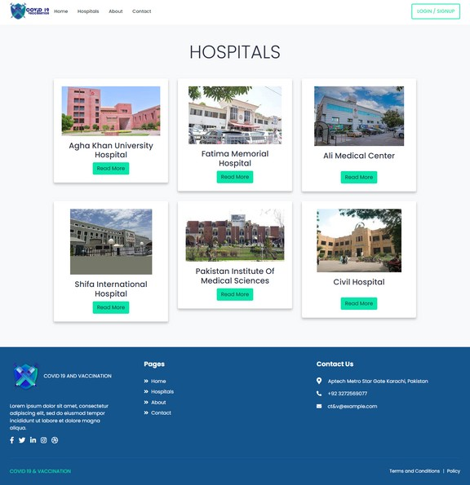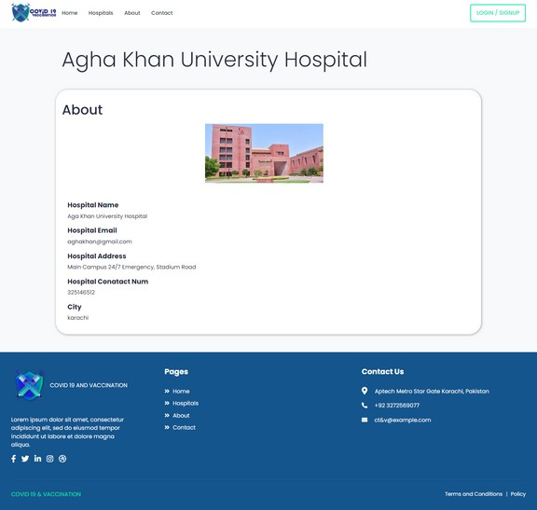

This is the **Hospitals page**, showcasing several hospitals. Two additional hospitals have been added, and by clicking on the 'Read More' button, you can view details about each hospital. Currently, you will find details only for **Agha Khan Hospital** and **Fatima Memorial Hospital**. Upon clicking the 'Read More' button for any of them, the about page will open, displaying information about the respective hospital. All the data shown on the about page is fetched from the **database** using **PHP**.

## About Page

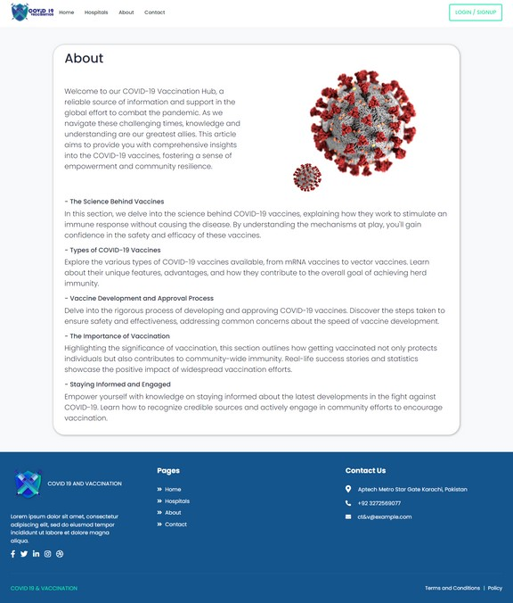

This is the **About page** where you can read about **COVID** and gain knowledge. From here, you can knowledge about **COVID**.

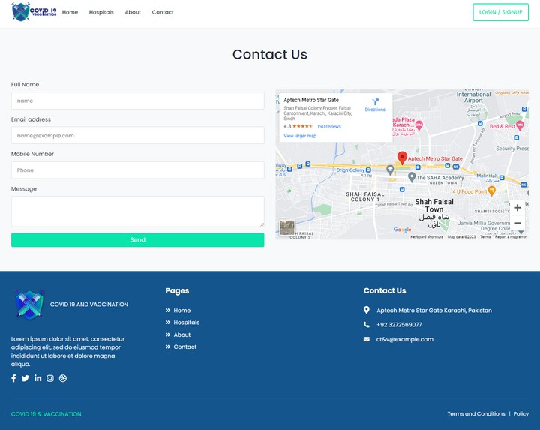

This is the **Contact page**. You can contact us by filling out the form provided. If you need any additional information.

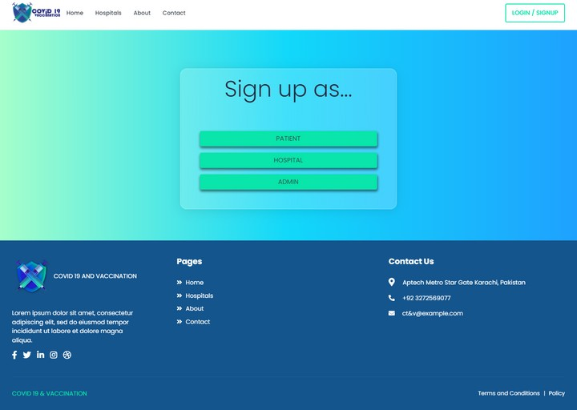

This is the personalized section accessible after logging in. Once you log in, you'll have access to exclusive content tailored to your profile. This may include personalized updates, saved preferences, and other features designed to enhance your experience on the platform.

From here, there are three types of users who can navigate to the login page. If you're a patient, you can click on Patient. If you're a hospital manager, you can click on Hospital. The third option is for administrators, and upon clicking, you will be directed to the login page..

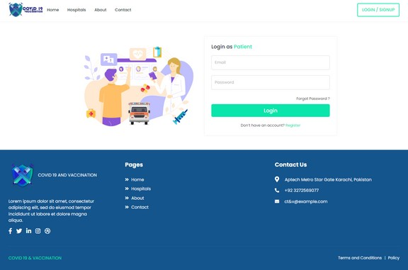 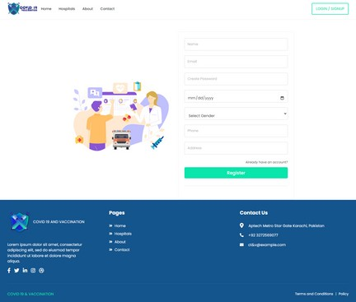

This page serves as the login and registration portal for patients. If you've already registered, you can directly enter your email and password to access your patient dashboard. However, if you haven't registered yet, you'll need to complete the patient registration process.

Similarly, for hospitals, the login and registration page follows the same pattern. To access the hospital dashboard, the admin must activate your account after you register with your hospital information. Until the admin activates your account, you won't be able to log in to the hospital dashboard.

## Patient Dashboard Page

After logging in as a patient, you'll encounter an interface displaying your personal information on the front. If you look to the sidebar, you'll find three options:

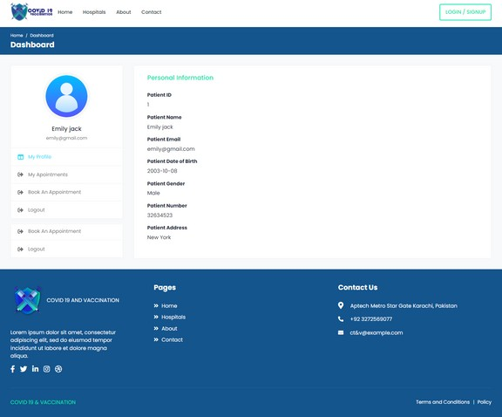

**My Appointments:** Here, you can view the status of your appointments they are accepted, rejected, or still pending. When your appointment is approved, a pop-up notification will appear, informing you of the confirmation.

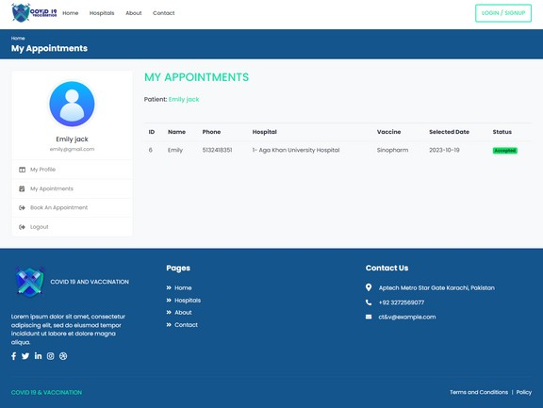

**Book Appointment:** In this section, you can book new appointments for COVID vaccination.

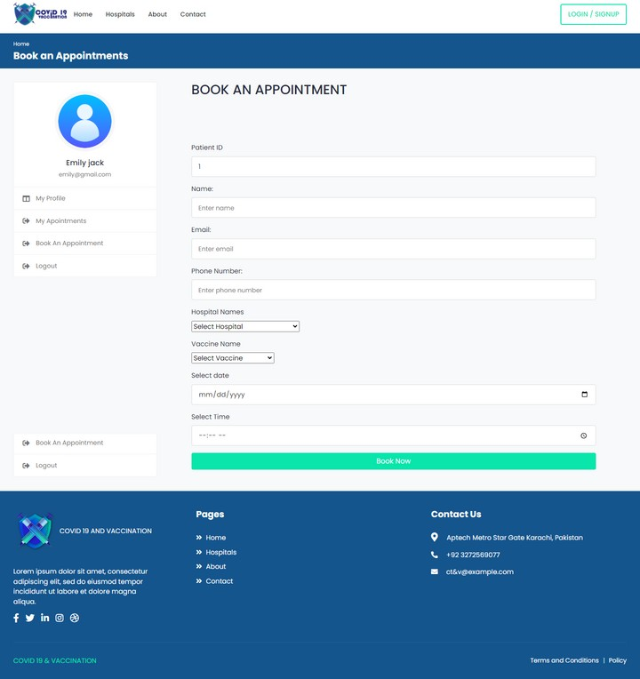

**Logout:** The third option allows you to log out of your account, ensuring the security of your information.

## Hospital Dashboard Page

After logging in as a hospital, you'll encounter an interface where your hospital's name is displayed on the side. On the dashboard, at the top, you'll see the total number of appointments in your hospital. Below that, there will be a detailed list of appointments, indicating their status.

If an appointment status is pending, it means that the admin hasn't approved it yet, and you won't be able to proceed with the patient's vaccination until it's approved. Once the admin approves the appointment, the status will change to "approved by admin.Approved By admin hospitals:

**Email:** [aghakhan@gmail.com](mailto:aghakhan@gmail.com) **Password**: aghakhan

**Email:** [fatimahospital@gmail.com](mailto:fatimahospital@gmail.com) **Password**: fatimahospital

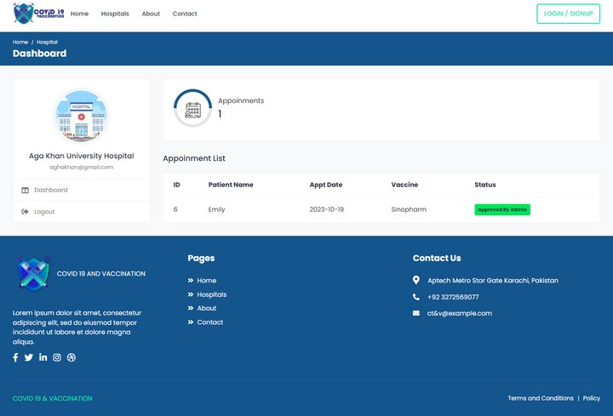

On the sidebar, you'll find a "Logout" option. The access to this dashboard is restricted to the hospital admin, who has been activated by the admin.

## Admin login Page

This is the admin login page, accessible only by the website administrator. To log in, enter the provided email and password below:

**Email:** [abaan@gmail.com](mailto:abaan@gmail.com) **Password:** 1234

**Email:** [muskan@gmail.com](mailto:muskan@gmail.com) **Password:** 4321

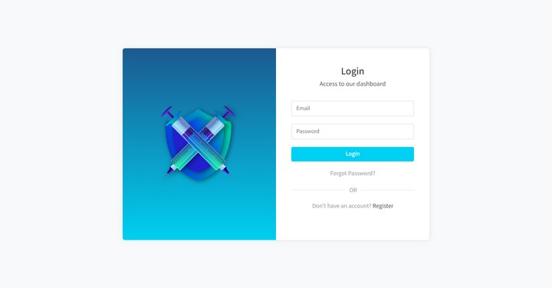

## Admin Dashboard Page

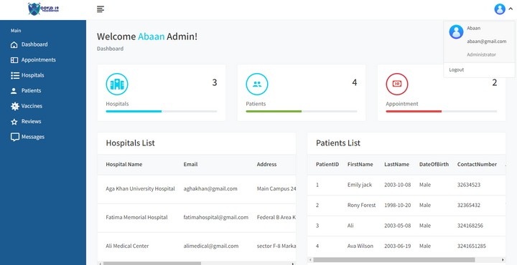

When the admin logs in, they will be presented with an interface displaying comprehensive details such as the number of patients, hospitals, and appointments. On the sidebar, the admin will find various pages, including Appointments, Hospitals, Patients, Vaccine, Reviews, and Messages. Each of these pages allows the admin to manage and handle different aspects of the website.

On the upper right side of the navbar, you will find an 'Account' option. Clicking on this will reveal a dropdown menu with a 'Logout' option, allowing you to log out of your account.

## Admin Dashboard

### -Appoinments Page

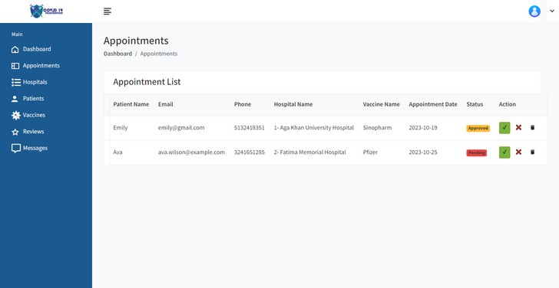

On the Appointments page, the admin will have access to a comprehensive list of all appointments along with their details. From this page, the admin can manage appointments by approving, rejecting, or deleting them.

### -Hospital Page

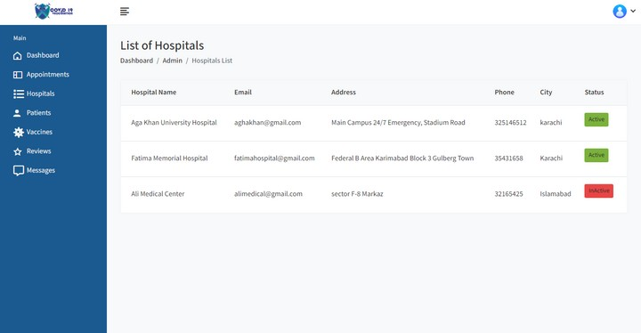

On Hospitals page, the admin will find a list of all hospitals. From here, the admin can manage hospitals by activating or deactivating them.

### -Patients Page

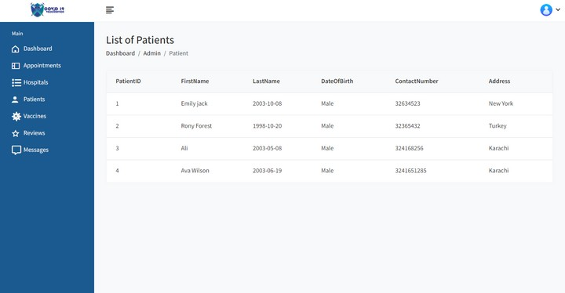

On the Patients page, the admin will have access to detailed information about all the patients.

### -Vaccine Page

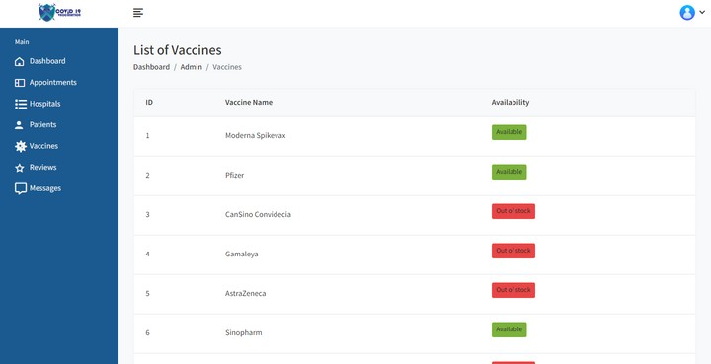

Vaccines page, the admin will have access to a complete list of all vaccines. From here, the admin can manage the availability of vaccines by marking them as either 'available' or 'unavailable'.

### -Reviews Page

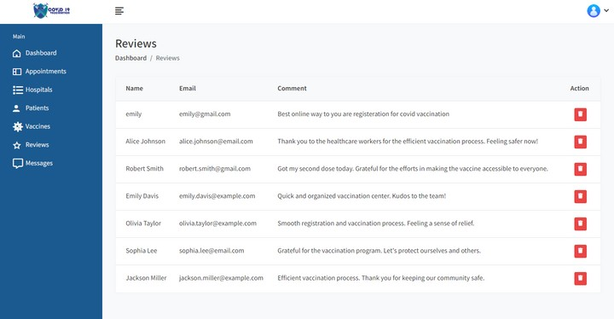

On the Reviews page, the admin will find a list of reviews submitted by patients. From this page, the admin has the ability to delete any review by clicking on the delete button associated with each review.

### -Messages Page

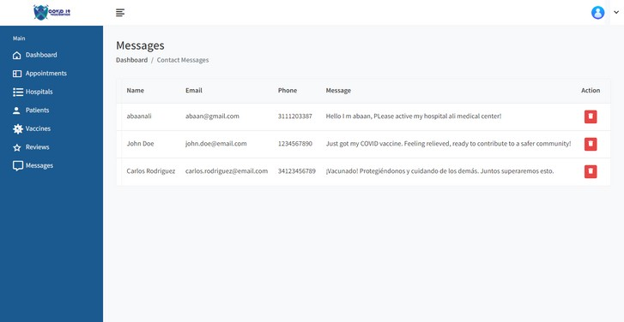

On the Messages page, the admin will find a list of all messages sent by users contacting the website. From this page, the admin can delete any message as needed.

That our website! We have used a languages on this website is:

**HTML** for structure

**CSS** for styling

**JavaScript** for dynamic behavior

**Bootstrap** for responsive design

**PHP** with **MySQL** for server-side functionalities and database management.

# TASK SHEET

|  |  |  |  |  |
| --- | --- | --- | --- | --- |
| Project Ref. No. | | Project Title | Date of Preparation of Activity Plan | |
| S.No. | Task | COVID 19 AND VACCINATION | Actual Days | Status |
| 1 | Analysis | 2 | DONE |
| 2 | Design | 4 | DONE |
| 3 | Development | 10 | DONE |
| 4 | Testing | 1 | DONE |
| 5 | Documentation | 3 | DONE |